Smart Gamification: Seven Core Concepts for Creating Compelling Experiences

Amy Jo Kim, Shufflebrain

* Sustainable social systems
* Gambrian Explosion: Games are rapidly changing and no longer look how they did ten years ago. Instead they are taking on new forms and being played on new platforms - they are achieving new levels of ubiquity and variety
* Social games help us stay connected with one another
  + Important part of helping us achieve our goals

1. **Understand the social style of your players; who is playing and how do they like to engage?**

* In general, females like to collaborate; FarmVille and CityVille are dominated by collaborative mechanics
  + Points, badges, levels and leaderboards appeal primarily to Achievers and competitive young male audiences
* Social engagement verbs; cooperating, competing, exploring and self-expression
  + Competitive verbs (Brain Buddies); win, beat, brag, taunt, challenge, pass, fight
  + Cooperative verbs (CityVille); join, share, help, gift, greet, exchange, trade
  + Exploration verbs (Foursquare); view, read, search, collect, complete, curate
    - Appeal to Explorers, someone who enjoys exploring their environment + engage with the content
    - Explorers are generally less social
  + Expressive verbs (ModCloth); choose, customise, layout, design, dress up, show-off
    - Self-expression is one of the biggest drivers of both gameplay and purchase behaviour
    - 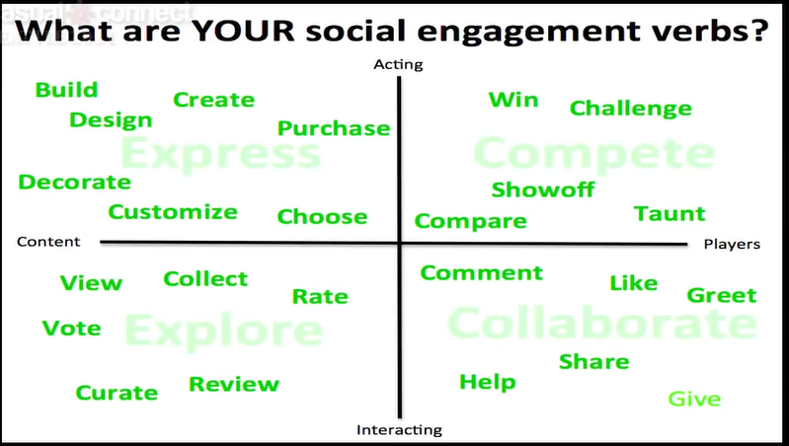ModCloth is not a game, but rather a game-like system

1. **Design for the three key stages in the player lifecycle**

* Newbie (onboarding)
  + Need to learn the ropes
  + What can you teach people for the first 1 to 2 months of entry level play? What is the arc of learning? (welcome, goals, progress and achievable reards
* Regular (habit-building)
  + What is it that is going to build your game into a daily or weekly habit?
  + Regulars need fresh content/activities/challenges to keep them engaged and coming back
* Enthusiast (mastery)
  + 2-5% of your players who really get into the game, they have different needs to other players
  + Enthusiasts need exclusivity, recognition and impact that they can have on the world
* PROTIP: create an elder game
  + Create systems that identify, leverage and empower your enthusiasts
  + What can your most avid players do that is different to what others can do

1. **Put PERMA into your activity loops**

* An idea from positive psychology founded by Martin Seligman – several key factors that are common in people that report happy lives and self-identified happiness
  + Positive emotions: experiencing joy, pleasure, fun, safety etc.
    - Powerful in games as they are good at provoking positive emotions in people e.g. fun
    - Distinguishing between pleasure and enjoyment is important in this element of the model
      * Pleasure is connected to satisfying bodily needs for survival (thirst, hunger etc.) whereas enjoyment comes from intellectual stimulation and creativity
      * When someone enjoys the tasks in their lives, they are more likely to persevere and battle challenges through creative and alternative solutions
    - Gamification does not necessarily mean making something fun, but could also be about enhancing the feeling of trust or the feeling of discovery
    - Ask yourself what positive emotion is at the core of what I am trying to design for and think about how you would elicit that
      * E.g. FarmVille: visual pleasure in planting and harvesting crops, self-expression in choosing what to plant and how to lay it out
      * Foursquare elicits serendipity, Amazon keeps you informed and is about building trust
  + Engagement/Flow: being consciously involved in our activities
    - We all need something in our lives that entirely absorbs us into the present moment, creating a ‘flow’ of blissful immersion into the task or activity
    - Every game has an engagement loop where there is an activity that you are involved in and ideally if it’s a game you are making visible progress, if the player doesn’t see it then it didn’t happen
    - Engagement changes during a player’s lifecycle, what’s engaging to a new player is going to be very different than what’s engaging to a master
    - See if you can sketch out an engagement loop for each stage of the player lifecycle. What would it look like? What would be interesting to them?
      * Think about the difference between novice and master when you’re designing your engagement loops
      * Do they want a leaderboard or to curate content?
      * Do they want to review beta features before anybody else?
  + Relationships: enjoyable/supportive interactions with others
    - Humans are social animals that thrive on connection and emotional/physical interactions with others
    - Building relationships with peers or friends is important for spreading joy
  + Meaning: creating a purposeful narrative
  + Accomplishment: completing goals and following core values

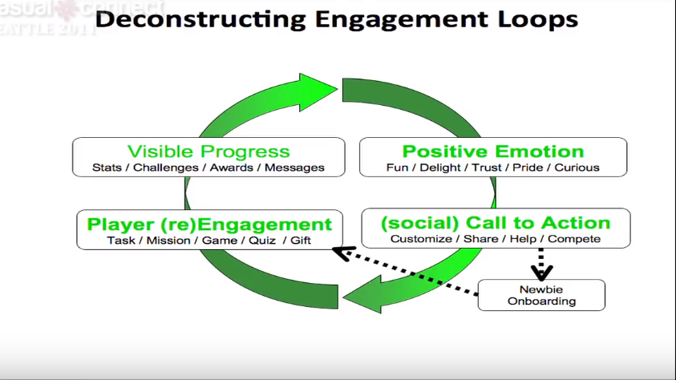

1. Light the way to mastery with **progress mechanics**

* If you have designed a great experience, the progress mechanics light the way along the journey to mastery
* Think about the journey you are taking your players on, how can you light the way and encourage them to keep playing, but also show them where they are headed?
* **The mechanics guide you towards learning and mastery**
  + What are you learning?
  + How does the game communicate to you that you’re learning, reward you and remind you that you’ve learned?
  + How does it let you apply that learning to new challenges? This is what keeps you engaged
* Mechanics, dynamics and aesthetics make up the player’s journey
  + **Game dynamics** are patterns over time: Progressive unlocks, pacing, appointments, reward schedules and dynamic systems
    - What happens over time is known as behavioural psychology and reinforcement schedules
    - If you have certain patterns of reinforcement over time that have variability in them, these are much more “addictive” than a straightforward “do this, get that.”
    - Patterns can be programmed into game systems, a blend of something you can count on with a certain element of suprise – reward schedules 🡪 habits, surprise, addiction
  + **Game mechanics** make progress visible: Points, levels, leaderboards, badges, missions, virtual goods and player journey
    - Badges in Foursquare are a method of onboarding, they give you implicit goals and once you’ve mastered that then there are new things for you to do – they suggest what to try next and also show you where you have been on your journey
  + **Game aesthetics** evoke emotion: Curiosity, satisfaction, surprise, trust, delight, fun, envy, pride and connection
    - Everything that pulls it together: the art, the NPC, the way your friends are portrayed socially
  + Emotion is the thing that drives action and engagement, if the player isn’t moved in some way (angry, happy, delighted, relieved) they won’t tend to take action
  + **Sustained engagement (flow) is achieved by increasing challenge (mastery)**
  + You can use this model to design a compelling experience that keeps players hooked
  + PRO TIP: Deliver increased challenge and complexity as your players’ skill improve

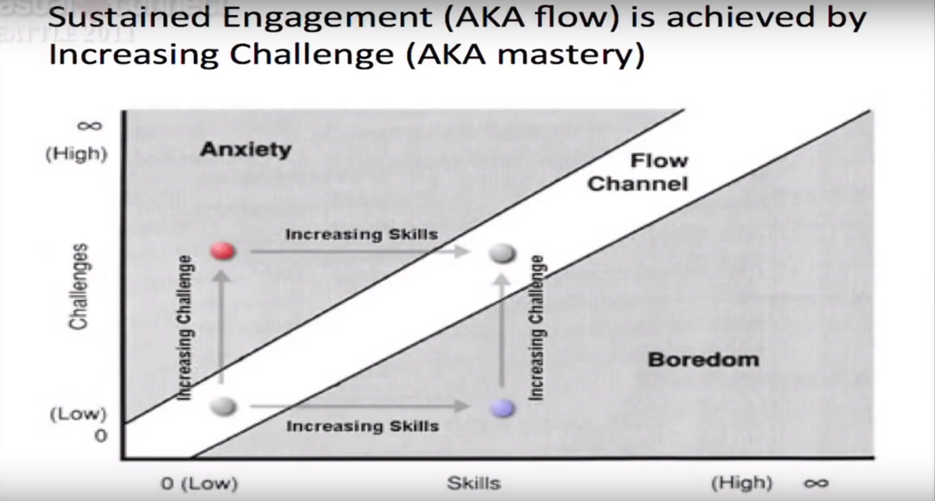

1. Motivate the players with **intrinsic rewards**

* Dan Pink’s book **Drive** identifies three key intrinsic motivators: **autonomy, mastery and purpose**
  + Autonomy – the desire to direct our own lives
  + Mastery – the urge to get better at something that matters
  + Purpose – also known as belonging, the desire to be part of something bigger than ourselves (meaningful play)

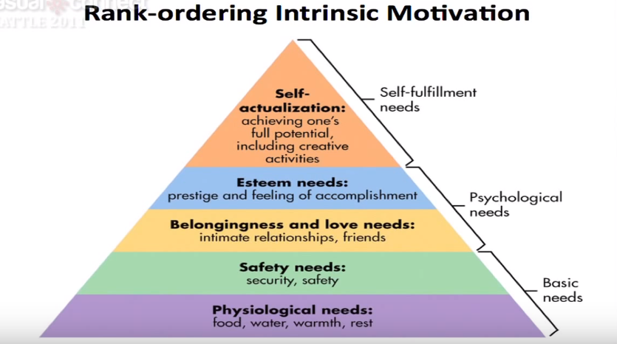

* If you haven’t satisfied the needs lower on the pyramid, then you cannot address those at the top. By looking at this, we can identify the unmet needs of our target audience – we can use this to design our experience
* Badges and points tell you if you have mastered something, but the actual act of mastery is very compelling to people
* **Intrinsic value > extrinsic rewards** so figuring out which intrinsic value you are aiming for can be very powerful
  + Intrinsic values: Belonging, autonomy, mastery, power, meaning, learning, self-knowledge, sex, love and fun
  + Extrinsic rewards: Points, levels, badges, quests, progress bars, gold stars, money, prizes and leaderboards
* **Extrinsic motivators are good for task completion but doesn’t get you sustained motivation**
* PRO TIP: Use feedback and rewards to support intrinsically motivating activity

**ModCloth Case Study: An Approach to Smart Gamification**

* ModCloth create a crowdsource custom clothing line inside of their boutique by utilising an engagement loop 🡪 highly collaborative
* They discovered that it wasn’t the item with the most votes that caused it to sell out, but those with the most discussion, argument and passion around them
* Players and their social style are very much expressive
* Their unmet need/intrinsic motivation: “I express my individuality and style with cute clothes”
* The business need was mitigating inventory risks – making sure they ordered items that would sell
  + Introduced a system with a **core engagement loop** where you can vote on the clothes you liked: Sample scouted 🡪 Voting starts (pick it/skip it) 🡪 Winners picked based on most votes/comments 🡪 Winners launched 🡪 Voters notified
* **Key engagement verbs:** Purchase, taunt, comment, choose, showoff, view, collect and vote
  + Clustered around the expressive quadrant with a small amount of competing and exploring – highly catered to the target audience
* **Ask yourself “what can my players learn and accomplish by playing the system?”**
* Understanding what motivates your players and understanding if they have an unmet need is the important starting point to making use of these processes
  + What is missing in their lives? What are they looking for? What is their aspirational need?

Newbie to Big Spender: Understanding the Player Lifecycle

Emily Greer

* Games that are consistently doing well on Kongregate are nearly all multiplayer and all have deep strategy in them: collectible card games, empire building
  + Single player games that incorporate social environments or elements of multiplayer are also successful
* Big spenders are a really big deal and requires commitment
* Non-repeats, repeats (2-9 plays), regs (10-49 plays), committed (50+ plays)
  + 1st stage: non repeats
    - This stage is critical, you need to show off the core gameplay to draw players in – a tutorial should not be teaching them the functions but making them want to play more
    - Give them a feeling of strong initial progress
    - Leave them wanting a bit more – they need a goal they couldn’t achieve, cut them off in a way that leaves them thinking about your game and wanting to come back (appointment mechanics and energy systems are a good way of doing this)
    - Don’t try to sell in the first session – at best it will distract the player or turn them away from your game, ultimately selling nothing anything (around 9 or 10 games is an inflection point for player purchases)
  + 2nd stage: repeats
    - Still mostly about involving the player in the game, you’ve got their interest and they liked what they saw so it is time to work on a deeper attachment
    - The **progress the player is making at this point should be visible (to themselves and possibly other people**), social and possibly multiplayer in terms of seeing progress but not true multiplayer gameplay since they are still figuring out the game. Everything you do means more when others can see it and it is in a social context
    - Multiplayer can be good but needs to be gentle at this stage
    - Get players into the store with **free currency**, start giving them a sense of value for the things they can buy but while sales are possible in this stage, you should not actively try to sell as players in this stage will still be price sensitive and value conscious
  + 3rd stage: regulars (10-49 plays)
    - Progress can slow down as the level of challenge increase, this makes the player more substantially engaged in your game
    - There needs to be a gradual shift to end-game, including social and multiplayer elements are key at this point – guilds are highly successful
    - Some sort of competitive element is important, but it doesn’t need to be strict PvP
    - Players at this stage are usually ready to start buying cost-effective, impactful items – first time buyer packages or promos would make sense, and this will help to begin ramping purchases up
  + 4th stage: committed players (50+ plays)
    - Keep their interest by including content expansions, new features and modes – changing players expectations is key
    - Still need to provide the player with goals (either group/community goals or individual goals), but progress can be slow
    - In-game friends will keep players coming back
    - Players in this stage are not as sensitive to price as those in earlier stages (income allowing) and are more willing to pay for smaller gains or incremental upgrades
    - You can also begin to sell cosmetic items at this stage
    - Plan your items that you intend on selling to be infinitely varied/expandable

Drive: The Surprising Truth About What Motivates Us

Dan Pink

* At the heart of ‘Motivation 2.0’ are two simple ideas: *Rewarding an activity will get you more of it. Punishing an activity will get you less of it.*
* Sawyer Effect: Rewards can transform an interesting task into a drudge and by diminishing intrinsic motivation, they can send performance, creativity and upstanding behaviour toppling
  + Behavioural scientists often referred to these counterintuitive consequences of extrinsic incentives as “the hidden costs of rewards”
  + In an experiment where children were split into 3 groups to test the effect of rewarding an enjoyable activity, only *contingent*/expected rewards had the negative effect – when children didn’t expect an extrinsic reward, receiving one had little impact on their intrinsic motivation
    - This is because the expected rewards required them to forfeit some of their autonomy and ultimately drained the activity of its enjoyment factor
* “People use rewards expecting to gain the benefit of increasing another person’s motivation and behaviour, but in so doing, they often incur the unintentional and hidden cost of undermining another person’s intrinsic motivation towards the activity”
* Contingent incentives can result in a negative impact on overall performance
  + In an experiment performed by behavioural scientists, it was found that those who were offered a medium-sized bonus didn’t perform any better than those offered a smaller one, while those who were super-incentivised fared the worst out of all three.
* Rewards by their very nature can narrow our focus and dull creativity
  + In the “candle problem” those who were incentivised took three and a half minutes longer to solve the problem on average. It took them a lot longer to overcome “functional fixedness”, where they would only view the box as a container for the tacks rather than as a platform for the candle
  + This result is not true across all tasks, Amabile and others have found that extrinsic rewards can be effective for algorithmic tasks (those that depend on following an existing formula to a logical conclusion) as oppose to heuristic (breaking from the path to discover a novel strategy)



* Rewards and incentives can taint an altruistic act and “crowd out” the intrinsic desire to do something good
  + Group 1 were offered no monetary incentive to donate blood, it was purely voluntary – 52% of women in this group donated
  + Group 2 were offered 7 Swedish kronor (approx. $7) if they donated blood – only 30% of women in this group donated
  + Group 3 were offered a 50 kronor payment with an immediate option to donate the amount to a children’s cancer charity – 53% of women in this group donated
* Mixing rewards with inherently interesting, creative or noble tasks – deploying them without understanding the peculiar science of motivation – is a very dangerous game and often does more harm than good
* By neglecting the ingredients of genuine motivation – autonomy, mastery and purpose, “if-then” rewards limit what each of us can achieve
* When used improperly, extrinsic motivators can give us more of what we don’t want: they can encourage bad behaviour, create addiction and encourage short-term thinking at the expense of the long view
* Extrinsic goals, or goals imposed by others, can have similar dangerous side effects, their presence can restrict the wider view of our behaviour – goal setting can induce unethical behaviour
* “*Goals may cause systematic problems for organisations due to narrowed focus, unethical behaviour, increased risk taking, decreased cooperation and decreased intrinsic motivation”*
* Similarly, punishment can crowd out good behaviour rather than promoting it
* Rewards are addictive in that once offered, a contingent reward makes an agent expect it whenever a similar task is faced, which in turn compels the principal to use rewards repeatedly. Eventually the principal will be forced to offer larger rewards to achieve the same effect
  + These addictive qualities can also distort decision-making, anticipation of rewards activates the nucleus accumbens which may lead to an increase in the likelihood of individuals switching from risk-averse to risk-seeking behaviour
* As mentioned previously, extrinsic motivators (particularly tangible if-then ones) can limit our breadth (range) of thinking. However, they can also reduce the *depth* of our thinking – they focus our sights on only what’s immediately before us rather than what’s off in the distance
  + In some circumstances this can damage performance over time
* In environments where extrinsic rewards are most prominent, most people only work to the point that triggers the reward and no further
* By contrast, the elements of genuine motivation defy a short-term view e.g. mastery
  + Introducing an if-then reward to develop mastery usually backfires; short-term prize crowds out the long-term learning

Summary of the “Seven Deadly Flaws of Carrots and Sticks”

* They can extinguish intrinsic motivation
* They can diminish performance
* They can crush creativity
* They can crowd out good behaviour
* They can encourage cheating, shortcuts and unethical behaviour
* They can become addictive
* They can foster short-term thinking

Additional Sources

<https://www.cnet.com/news/jane-mcgonigal-shows-how-games-make-us-resilient/>

<https://positivepsychologyprogram.com/perma-model/>